**Objective:**The primary goal of this project was to assess and improve the prediction of default risk for publicly traded companies using the Altman Z-Score as a foundational model, and then enhance it with additional financial and market-based indicators to better capture a company's financial stability.

**Methodology:**

**1. Data Collection:**We retrieved financial data for 50 companies using the yfinance API using python in Google Colab. The data includes:

* + Total Liabilities
  + Current Assets
  + Total Assets
  + Current Liabilities
  + Retained Earnings
  + EBIT (Operating Income)
  + Revenue
  + Market Cap
  + Stock Return (%)
  + Volatility (%)
  + Operating Cash Flow

**2. Z-Score Calculation:**The Altman Z-Score was calculated using the standard formula:

Z = 1.2 * Working Capital / Total Assets + 1.4 * Retained Earnings / Total Assets + 3.3 * EBIT / Total Assets + 0.6 * Market Cap / Total Liabilities + 1.0 * Revenue / Total Assets

**3. Enhanced Score Development:**We extended the traditional Z-score with five additional features to construct a more holistic risk indicator:

* **Stock Return (%):** Reflects investor sentiment and market performance.
* **Volatility (%):** Measures risk or uncertainty in price movement.
* **Cash Flow:** Captures actual liquidity available for operations.
* **Working Capital:** Measures short-term financial health.
* **Market Cap:** Acts as a proxy for firm size, often linked to default risk resilience.

The **Enhanced Score** is a weighted combination:

Enhanced Score = Z + 0.3 * Cash Flow / Total Liabilities - 0.2 * Volatility (%) + 0.2 * Stock Return (%) + 0.5 * log(Market Cap + 1)

**4.Visualization:**

* A **Histogram of Z-Scores** was plotted to show the distribution of companies across risk categories.

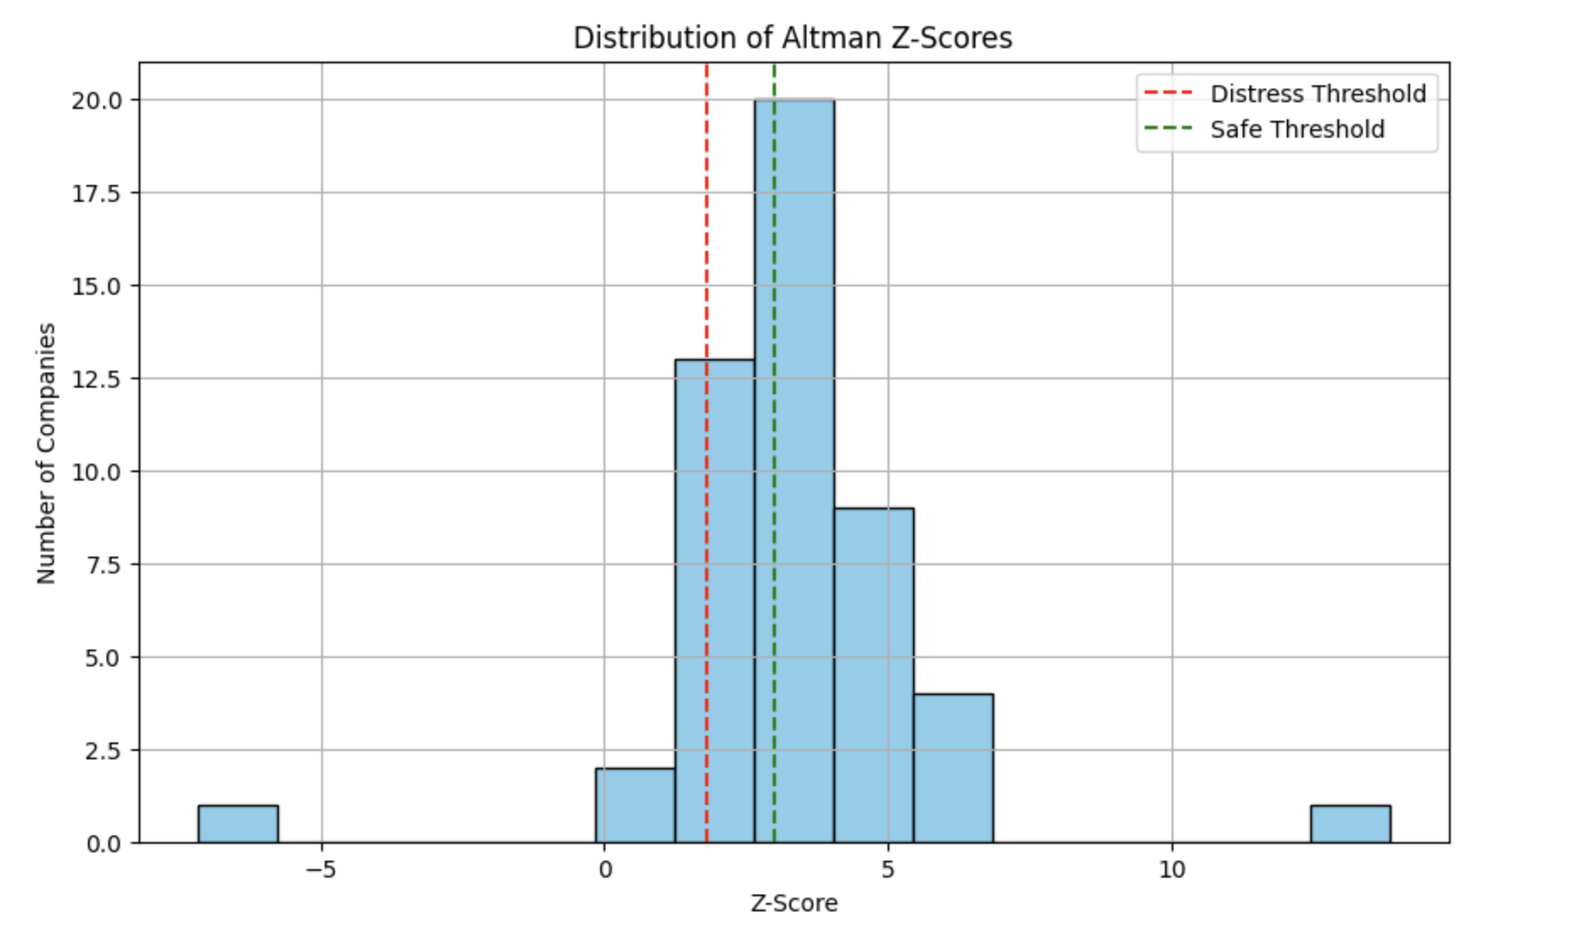

* A **Scatter Plot of Z-Score vs. Enhanced Score** visually demonstrated the correlation and divergence between traditional and improved risk assessments.

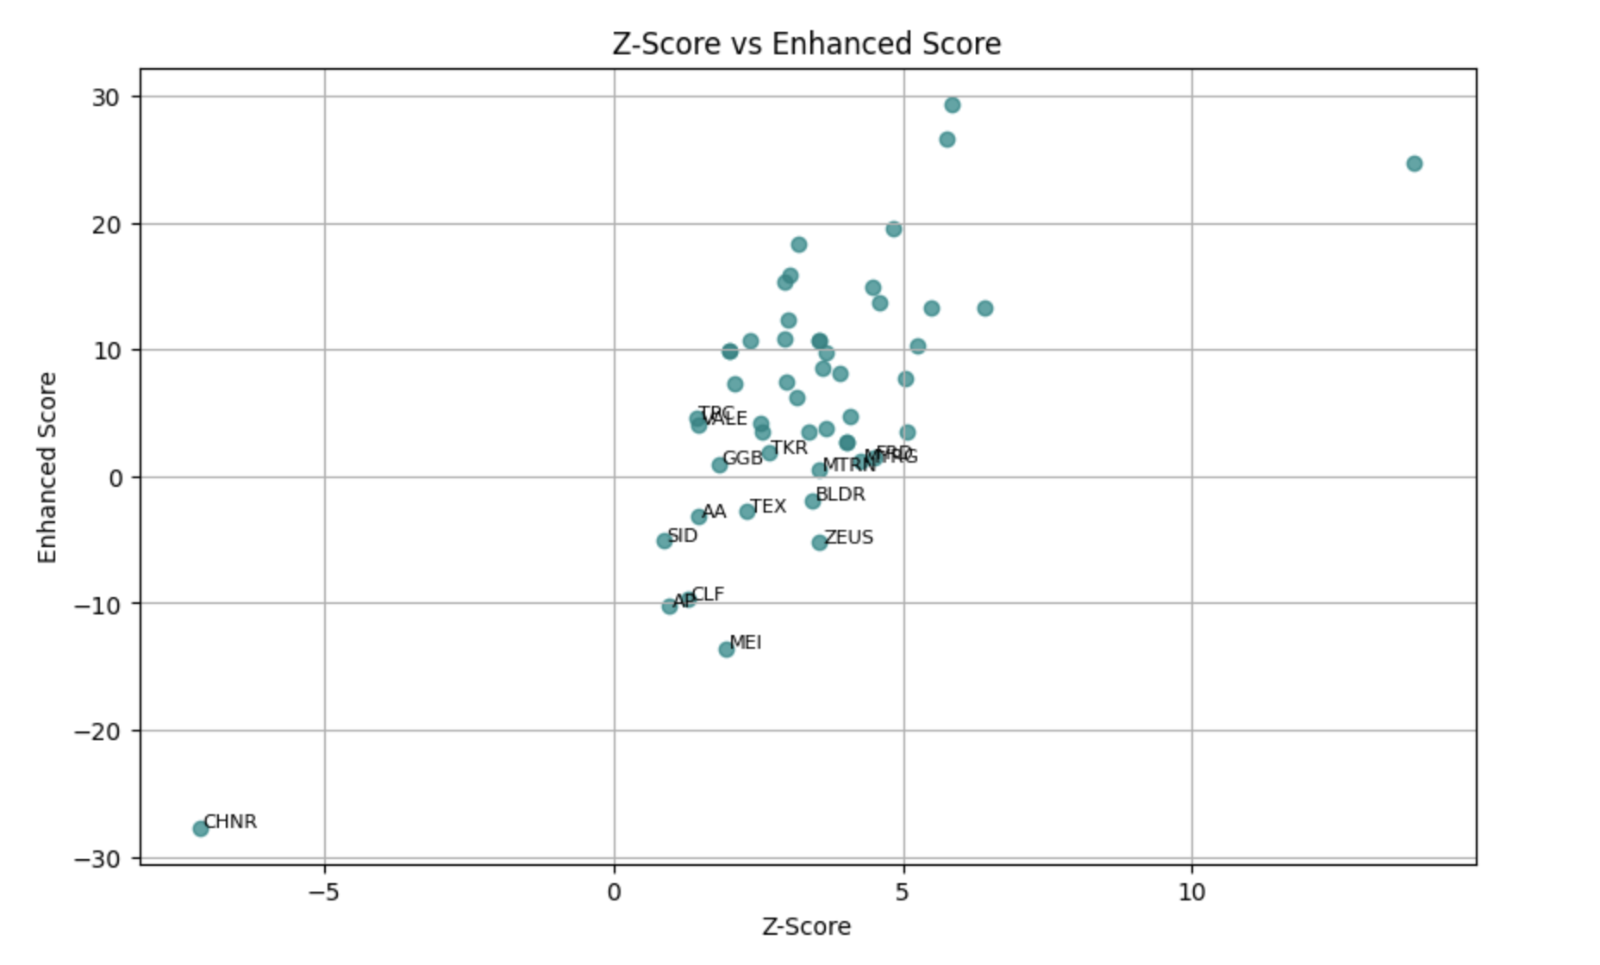

**Conclusion:**

This project successfully illustrates how combining accounting-based metrics (Z-Score) with market and operational signals provides a more robust and flexible model for default prediction. The enhanced scoring model, coupled with clear visualization, supports better decision-making in credit risk assessment, especially for portfolios within similar industries.